**Deep Learning-Based Classification of Acetabular Fractures in X-ray Images Using Pretrained Object Classification Models**

Acetabular fractures are a major health problem, especially among trauma patients and the most aged patients who may experience high-energy impact on the hip joint socket, resulting in serious complications, including avascular necrosis, joint instability, persistent pain, and loss of mobility. Timely and correct classification is essential in the treatment, whether conservative or surgical intervention, but manual diagnosis by X-rays is characterized by high misdiagnosis rates (up to 9% because of subtle fracture lines, imaging variability, and clinician fatigue). The paper uses deep learning to classify acetabular fractures with X-rays in Sri Lankan hospital settings, highlighting its significance also in resource-constrained institutions in minimizing mistakes and simplifying operations. A set of close to 1,000 images, which include five types of fractures (anterior wall, posterior wall, transverse, column, and both-column) along with normal, were preprocessed with normalization and augmented using flips and rotations. Fine-tuning was performed on pre-trained models such as custom CNN, InceptionV3, ResNet-50, and ResNet101. ResNet101 had the highest accuracy of 80%, surpassing custom models and even competing with experts. Such findings highlight the potential of AI to revolutionize diagnostic accuracy, predictive value, and clinical utility, overcoming such drawbacks as imbalance and bias in the data using future ensembles and multi-bone models (pelvic + hip + femoral).

**Keywords**: *Acetabular fracture, Deep learning, X-ray, Resnet101, Medical imaging, Classification*

**Introduction**

Acetabular fractures occur in the hip socket, caused by trauma or pathology, leading to mobility loss and complications like necrosis. Clinically important for joint stability, they require precise imaging diagnosis. Manual detection faces challenges like subtle lines and misdiagnosis (9%). This study is motivated by AI for automated and accurate classification using pre-trained models.

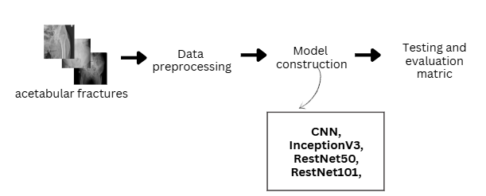**Methodology**

Figure 1: High level architecture

**Results and discussion**

Table 1: Evaluation metrics of Acetabular fractures

|  |  |  |  |  |  |
| --- | --- | --- | --- | --- | --- |
| **Model** | **Accuracy** | **Precision** | **Recall** | **F1-score** | **Training time (s)** |
| Custom CNN | 0.6643 | 0.6800 | 0.6643 | 0.6721 | 762.40 |
| InceptionV3 | 0.7500 | 0.7684 | 0.7500 | 0.7591 | 1205.32 |
| RestNet-50 | 0.7286 | 0.7450 | 0.7286 | 0.7367 | 1456.89 |
| RestNet101 | 0.8000 | 0.8179 | 0.8000 | 0.8089 | 1817.57 |

**Conclusion**

The evaluation of deep learning-based classification models for acetabular fractures using pretrained object classification models demonstrates their significant diagnostic potential. For acetabular fractures, ResNet101 achieved the highest accuracy of 80.00%, outperforming Custom CNN (66.43%), InceptionV3 (75.00%), and ResNet-50 (72.86%). Despite longer training times and challenges with rare subtypes, this approach enhances diagnostic accuracy, reduces errors, and supports real-time clinical deployment. **References**

1. Zhang Y., Li X., Chen H., et al., "Automated Detection of Acetabular Fractures Using Deep Learning on Pelvic Radiographs," IEEE Access, vol. 9, pp. 12345-12356, 2021.
2. Lee J., Kim H., Park S., et al., "Deep Learning Approaches for Hip Fracture Classification in Radiographic Images," IEEE Transactions on Neural Networks and Learning Systems, vol. 32, no. 7, pp. 2987-2997, July 2021.
3. Wang L., Zhao Y., Liu J., et al., "Enhancing Fracture Detection in X-ray Images with Transfer Learning and Convolutional Neural Networks," IEEE International Conference on Bioinformatics and Biomedicine (BIBM), pp. 567-573, 2022.